Door opens for permanent migration to Australia for low-skill workers without great English, but there's a catch
By political reporter Jackson Gothe-Snape
Updated 10 Dec 2018, 3:58pmMon 10 Dec 2018, 3:58pm
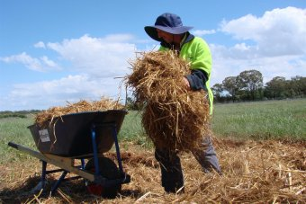
Photo: The Government claims new regional migration agreements will attract foreign farm workers. (Laurissa Smith: ABC Rural)
The Government has opened a gateway for foreigners with basic farm or hospitality skills to move permanently to Australia on a work visa.
New regional migration agreements for the Northern Territory and south-west Victoria will lower the criteria for skills, language and income for migrant workers.
And they will provide a pathway to permanent residency to these workers that previously did not exist.
However the Government is demanding migrants commit to living in these regions for at least three years before a permanent residency pathway is available.
Minister for Immigration David Coleman said the Government was improving the immigration program to better match the needs of specific locations.
"In particular, we are looking closely at ways of filling employment gaps in regional areas," he said.
The Government has shut options for permanent residency for hundreds of jobs in the migration program in the past two years, mainly through changes to occupation lists in the temporary skills shortage visa.
It has a meant a pathway to permanent residency through a work visa is only available to the workers the Government has deemed most desirable, mainly skilled occupations needed by Australian businesses.
But the new arrangements — known as designated area migration agreements (DAMAs) — lower the requirements, opening the door for migrants with less English fluency and lower skills and pay to move to Australia permanently.
A Northern Territory DAMA was already in place, but it did not include the offer of permanent residency.
Manuela Seiberth, a migration agent based in Darwin, said the new offer of permanent residency was "huge".
"I think this is a very good thing, in particular in light of the recent immigration law reforms which increased the requirements for most employer-sponsored visas and general skilled migration, such as higher qualifications, more work experience and higher English language skills," she said.
"The DAMA offers options for semi-skilled workers and provides flexibility with its concessions.
Typically, employment visas must be for workers with competent English and pay of at least $53,900 per year.
However, under the previous Northern Territory DAMA, a visa may be approved for a baker, barista or hairdresser with language or income less than these thresholds.
Under the new DAMA these workers will likely be given a chance to move to Australia permanently.
Ms Seiberth has provided advice to businesses under the previous DAMA in the Northern Territory.
She said it had mostly been used by tourism and hospitality providers for occupations such as bar supervisors and waitstaff.
"Northern Territory employers struggle to attract and retain skilled workers — I'm speaking from my own experience as a business owner and employer," she said.
"The main problems are the extreme tropical climate in the Top End and the remoteness."
The Northern Territory Government confirmed that new agreement includes a wider range of occupations — 117 in total, compared to 111 currently listed — together with tweaks to English and salary concessions and the offer of permanent residency.
NT Minister for Workplace Training Selena Uibo said all residents benefited when more people moved to the Territory.
"More people means more jobs, a stronger economy and more GST revenue, which means better schools, better hospitals, and more police."
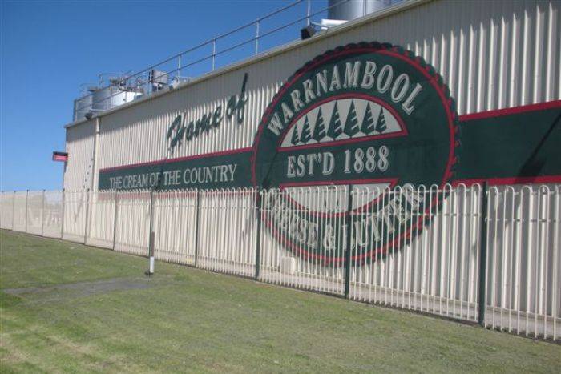Photo: Local MP Dan Tehan said the new migration agreement would benefit the local dairy industry. (Tony Allan )

DAMA for Warrnambool
A separate DAMA for the Warrnambool region promises to deliver migrant workers for the meat-processing, dairy and other agricultural sectors.
Dan Tehan, the Liberal MP for the local Wannon electorate, said the agreement addressed, "the risk that someone might come and do the job for six months then move to a capital city".
"What [migrants] would do is they would come in, fulfil the requirement — which would be three to four years working in the particular skilled-shortage area — then they would get on the pathway to
permanent residency — not in all instances, but in some instances," he said.
"Obviously there are criteria that they have to meet: anything with regards to breaking the law, etcetera, would obviously, could be prejudicial to them getting onto a permanent residency pathway."
The Government had discussed the potential for a five-year residency requirement for a regional visa.
Until the new DAMAs are signed, it's not clear exactly how long or under what conditions migrants will be required to stay in regions.
Visas granted under the existing regional framework are at their lowest levels in a decade
https://www.abc.net.au/news/2018-12-10/immigration-australia-skill-english-salary-concessions-regions/10355054

